1. In “Seat allocation Seat mapping” after the selection of seat types the seats are not showing and it we give negative number of seats it keeps on loading than terminating with error message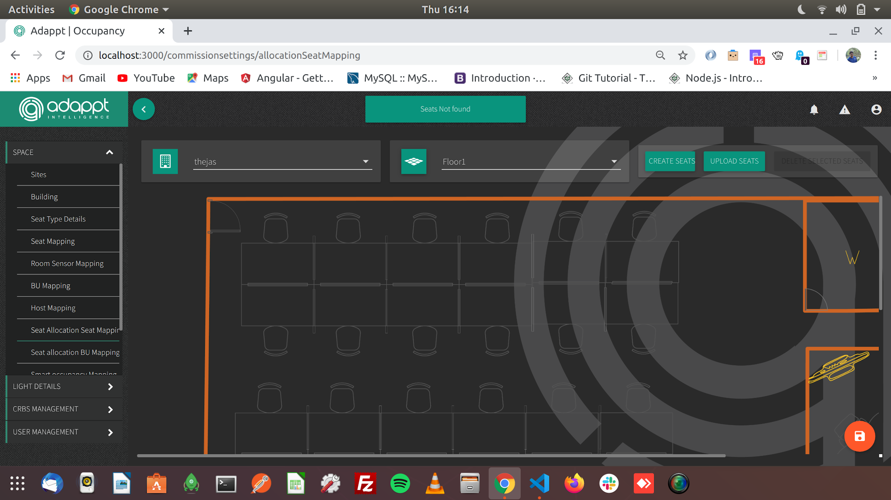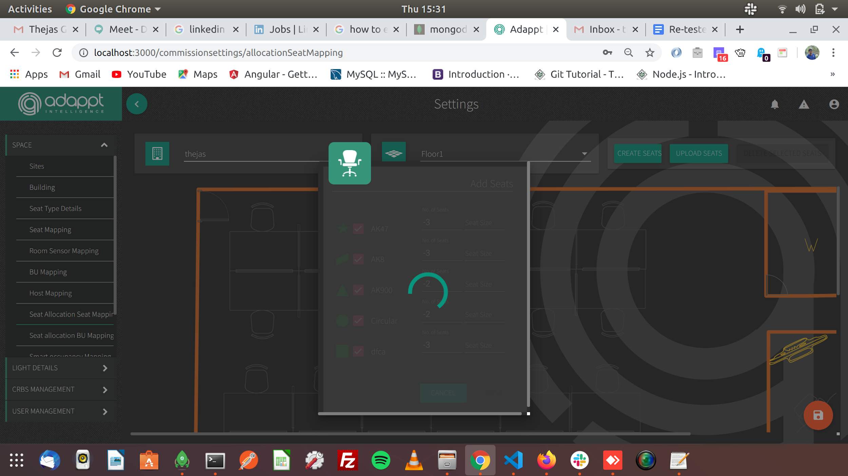
2. The recurring session of date is given till 30th may(only for monday to thursday) when we try book on 29th i.e friday we get error message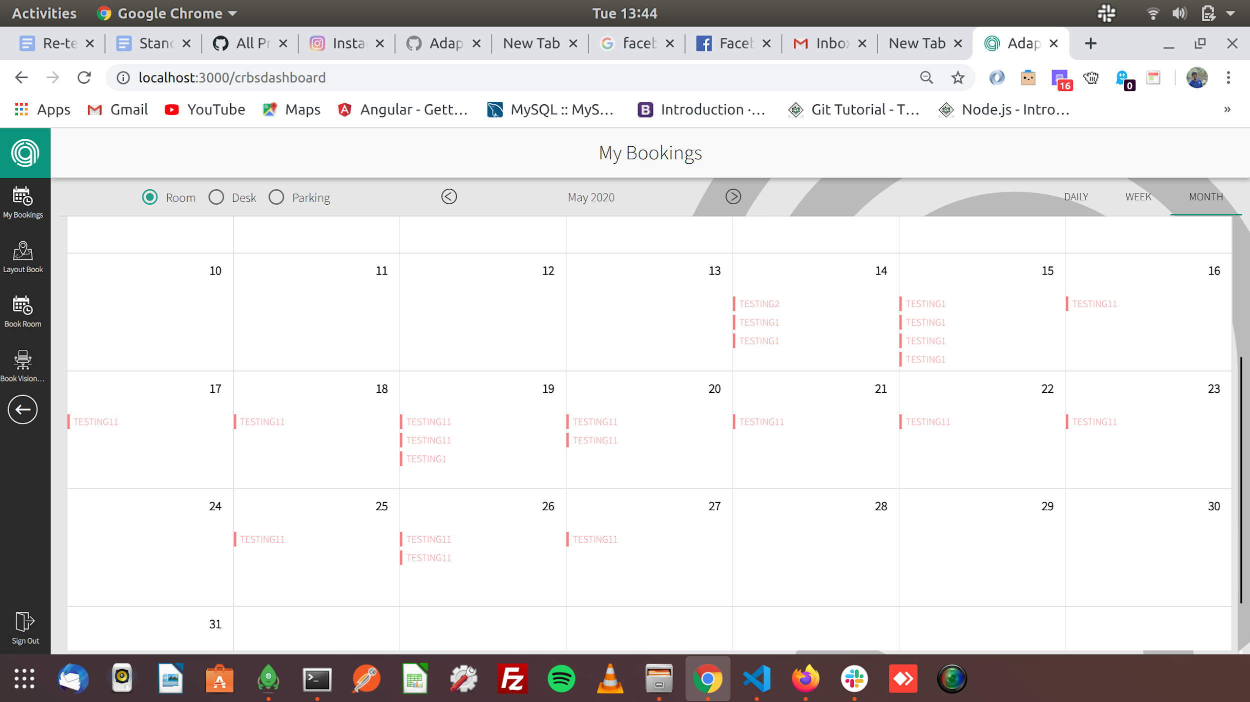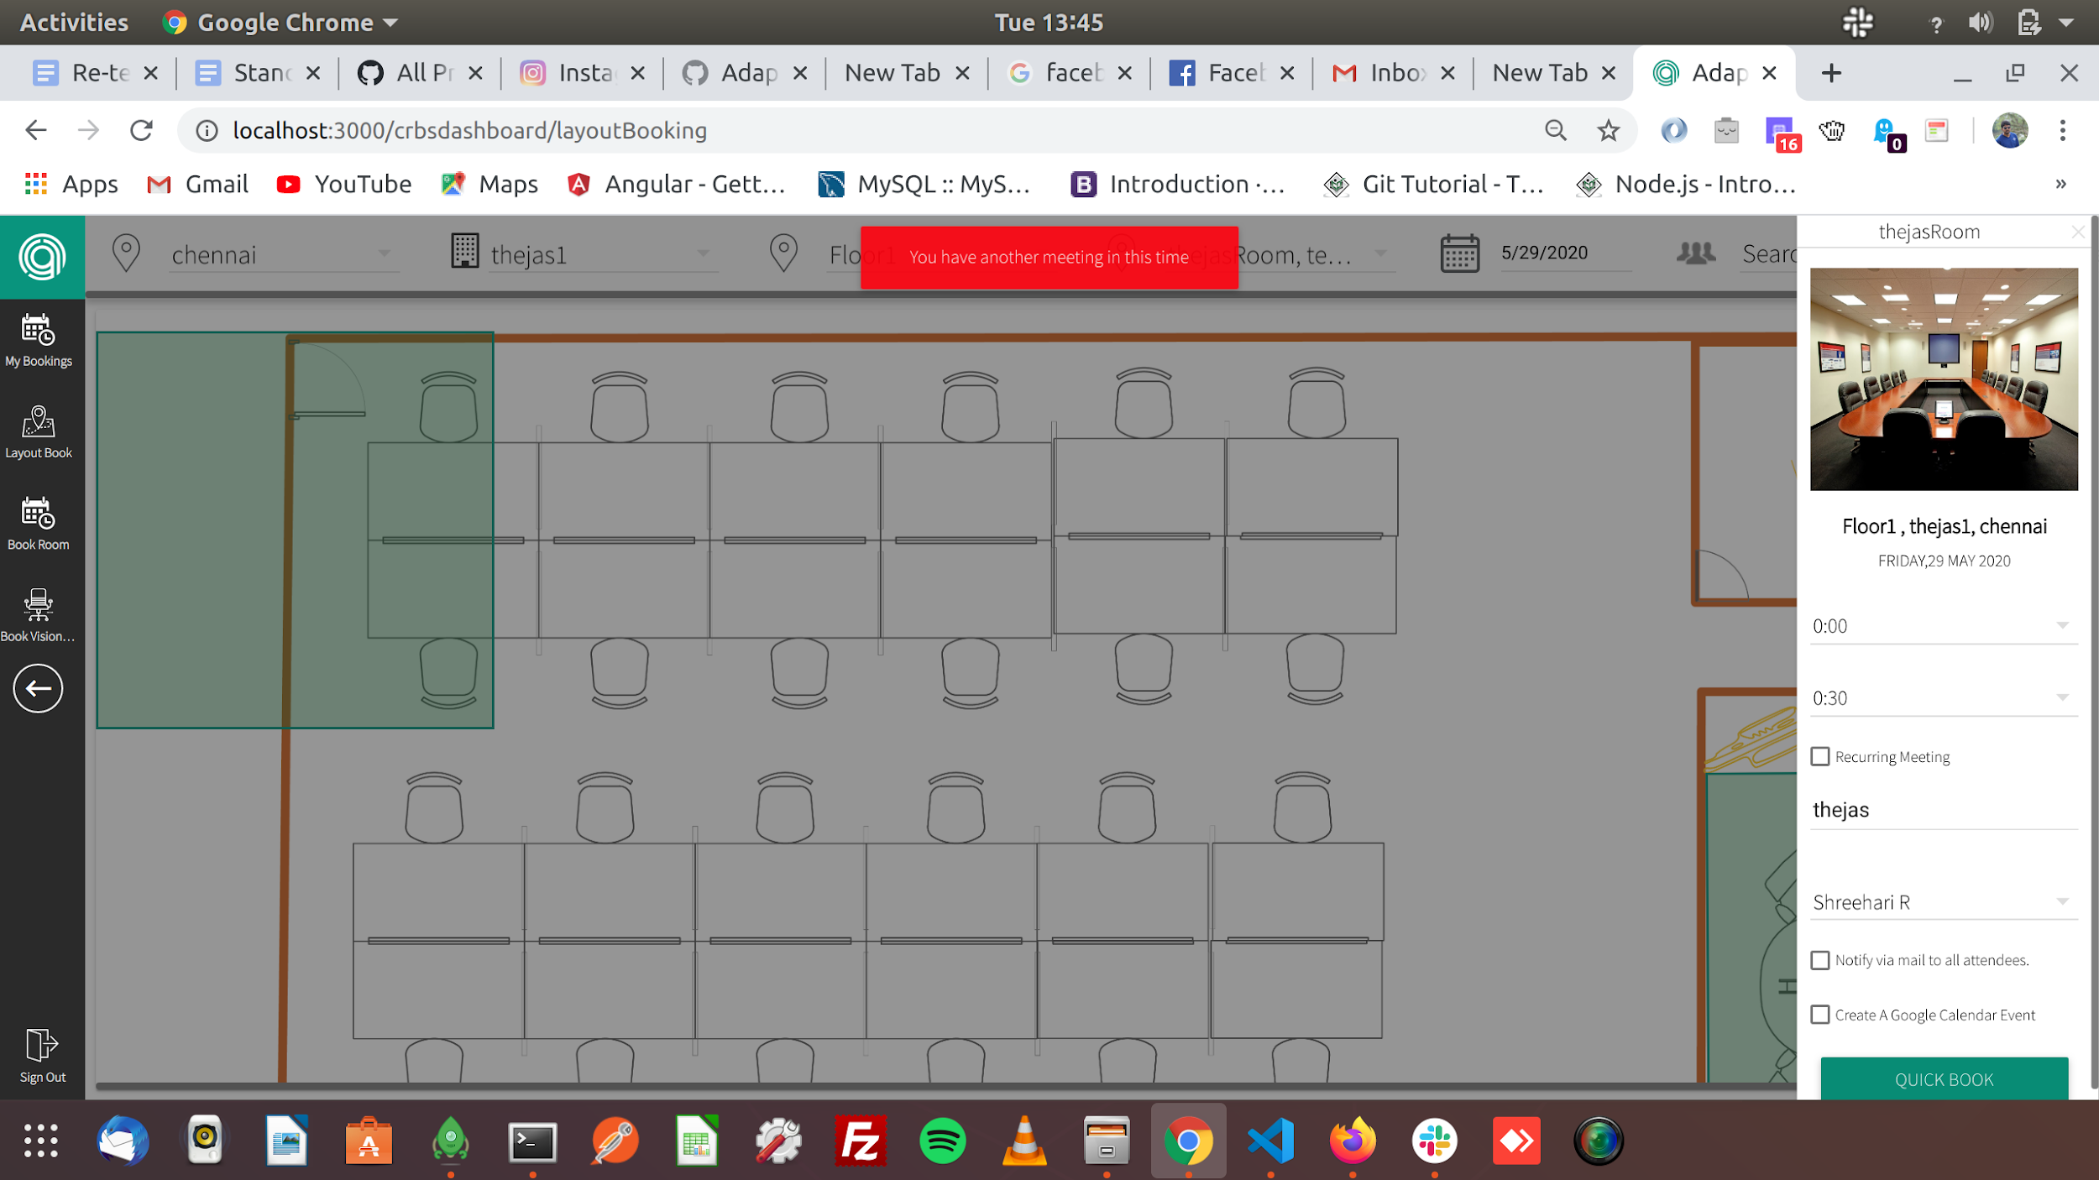
3. Please align “select all” checkbox and radio buttons in one-line and “Back” button not working in LMS Analytics(Controls and Layout pages working fine) page please check this once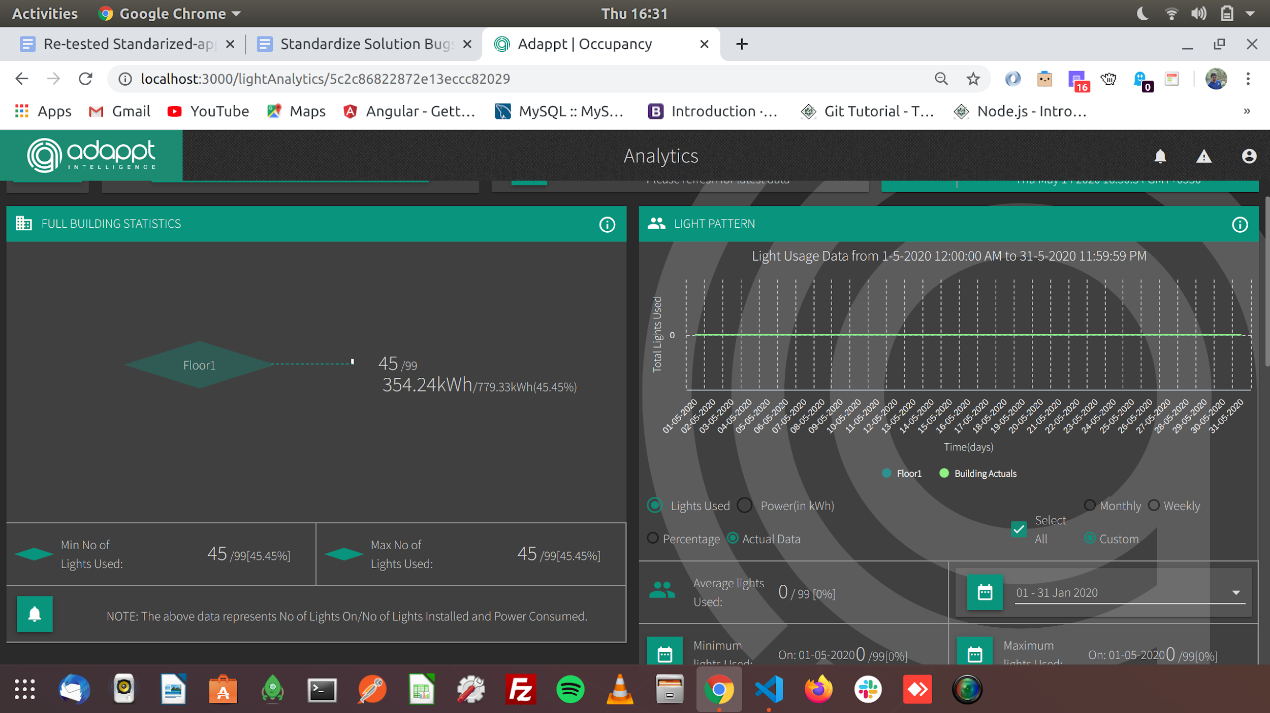
4. For the future dates of booking it should start from 00:00 but its taking current time in “Book Room”...please check this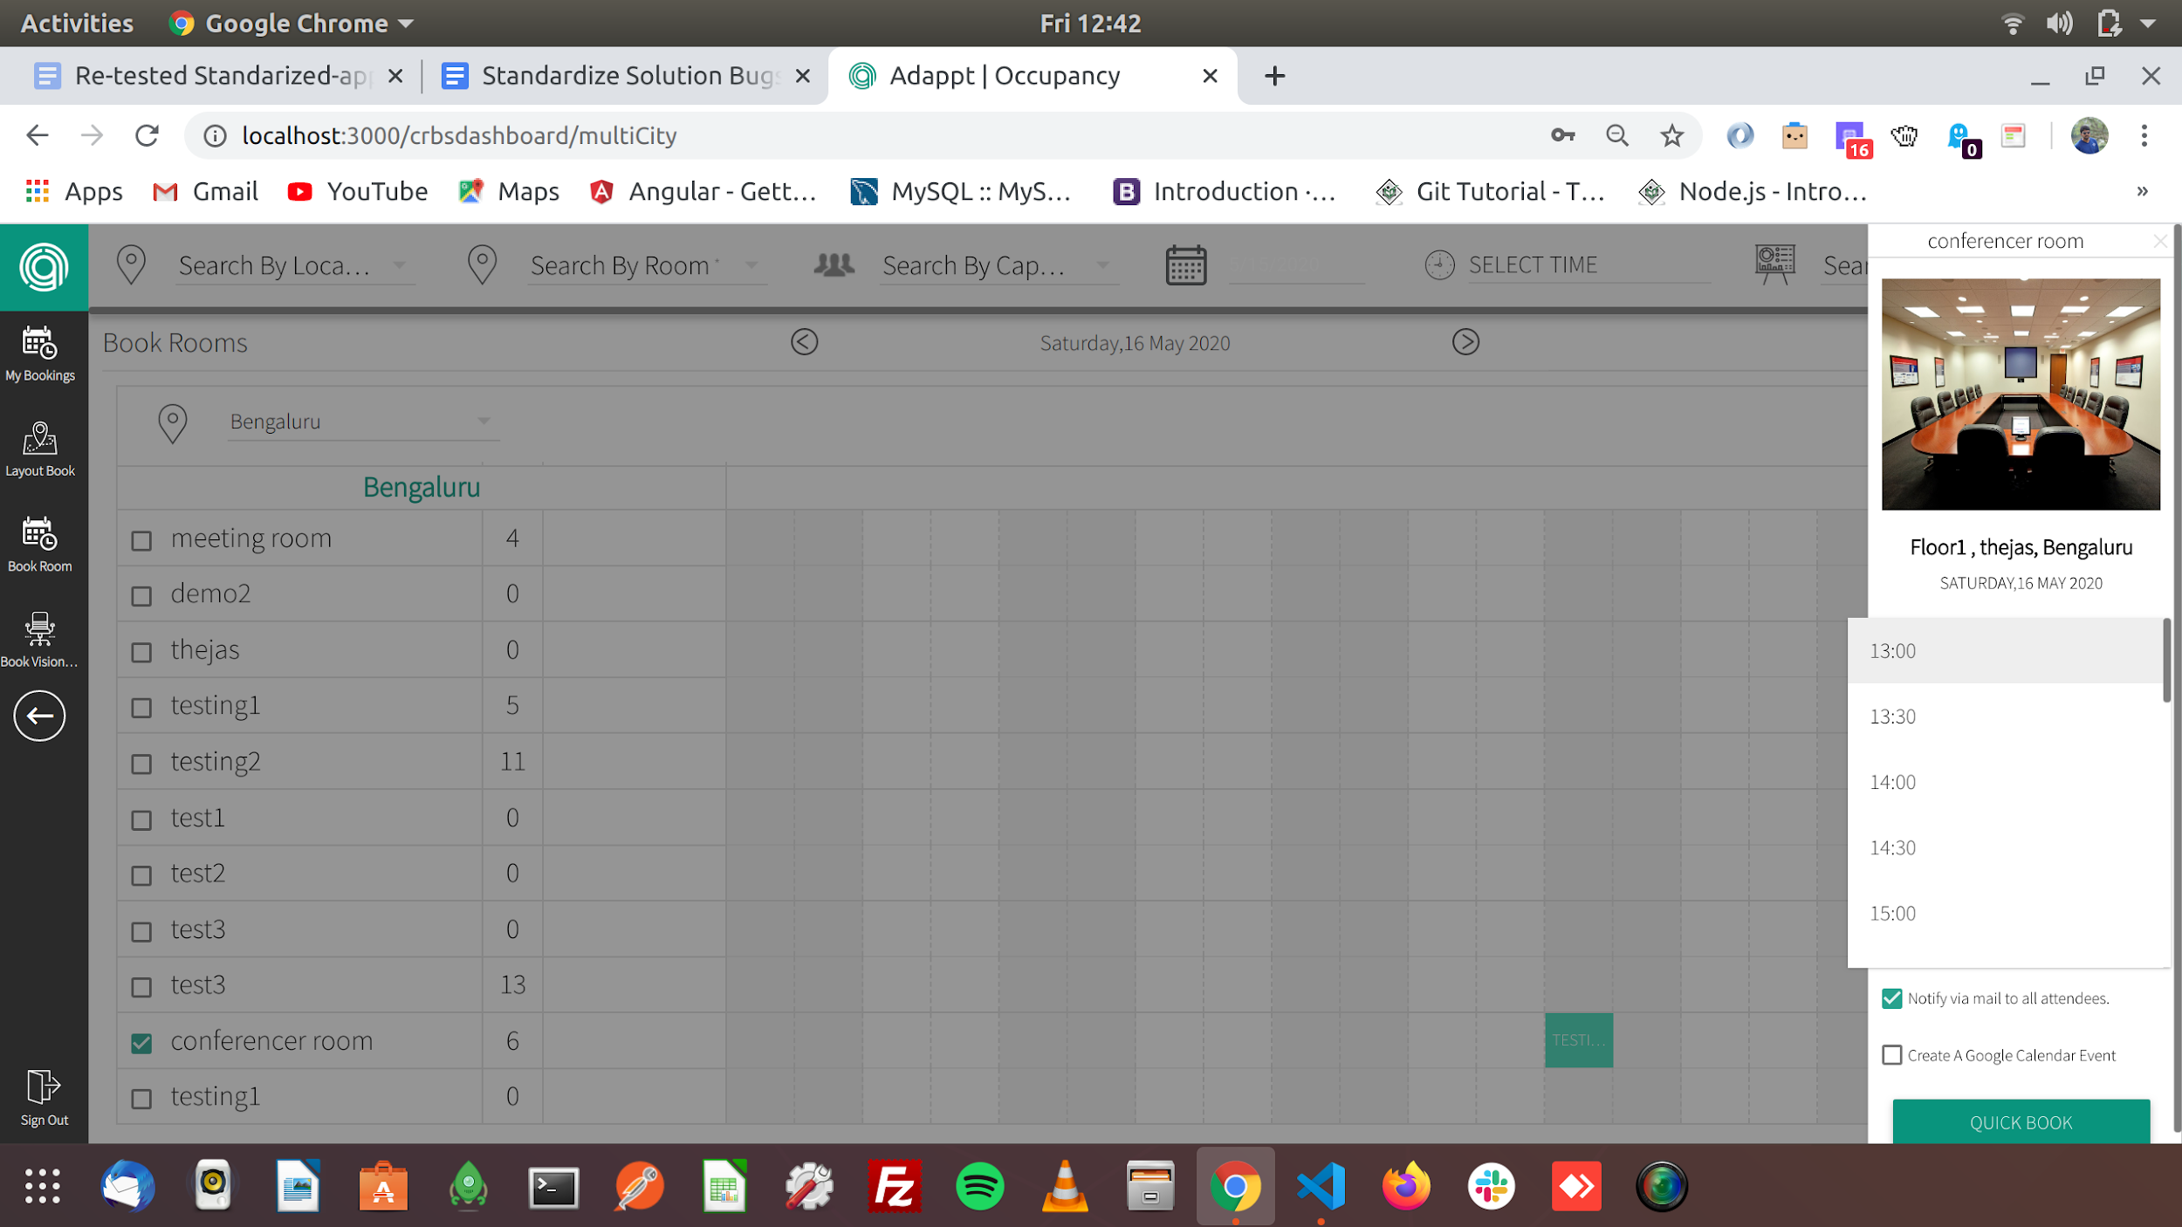
5. The future bookings are not showing in “My Bookings”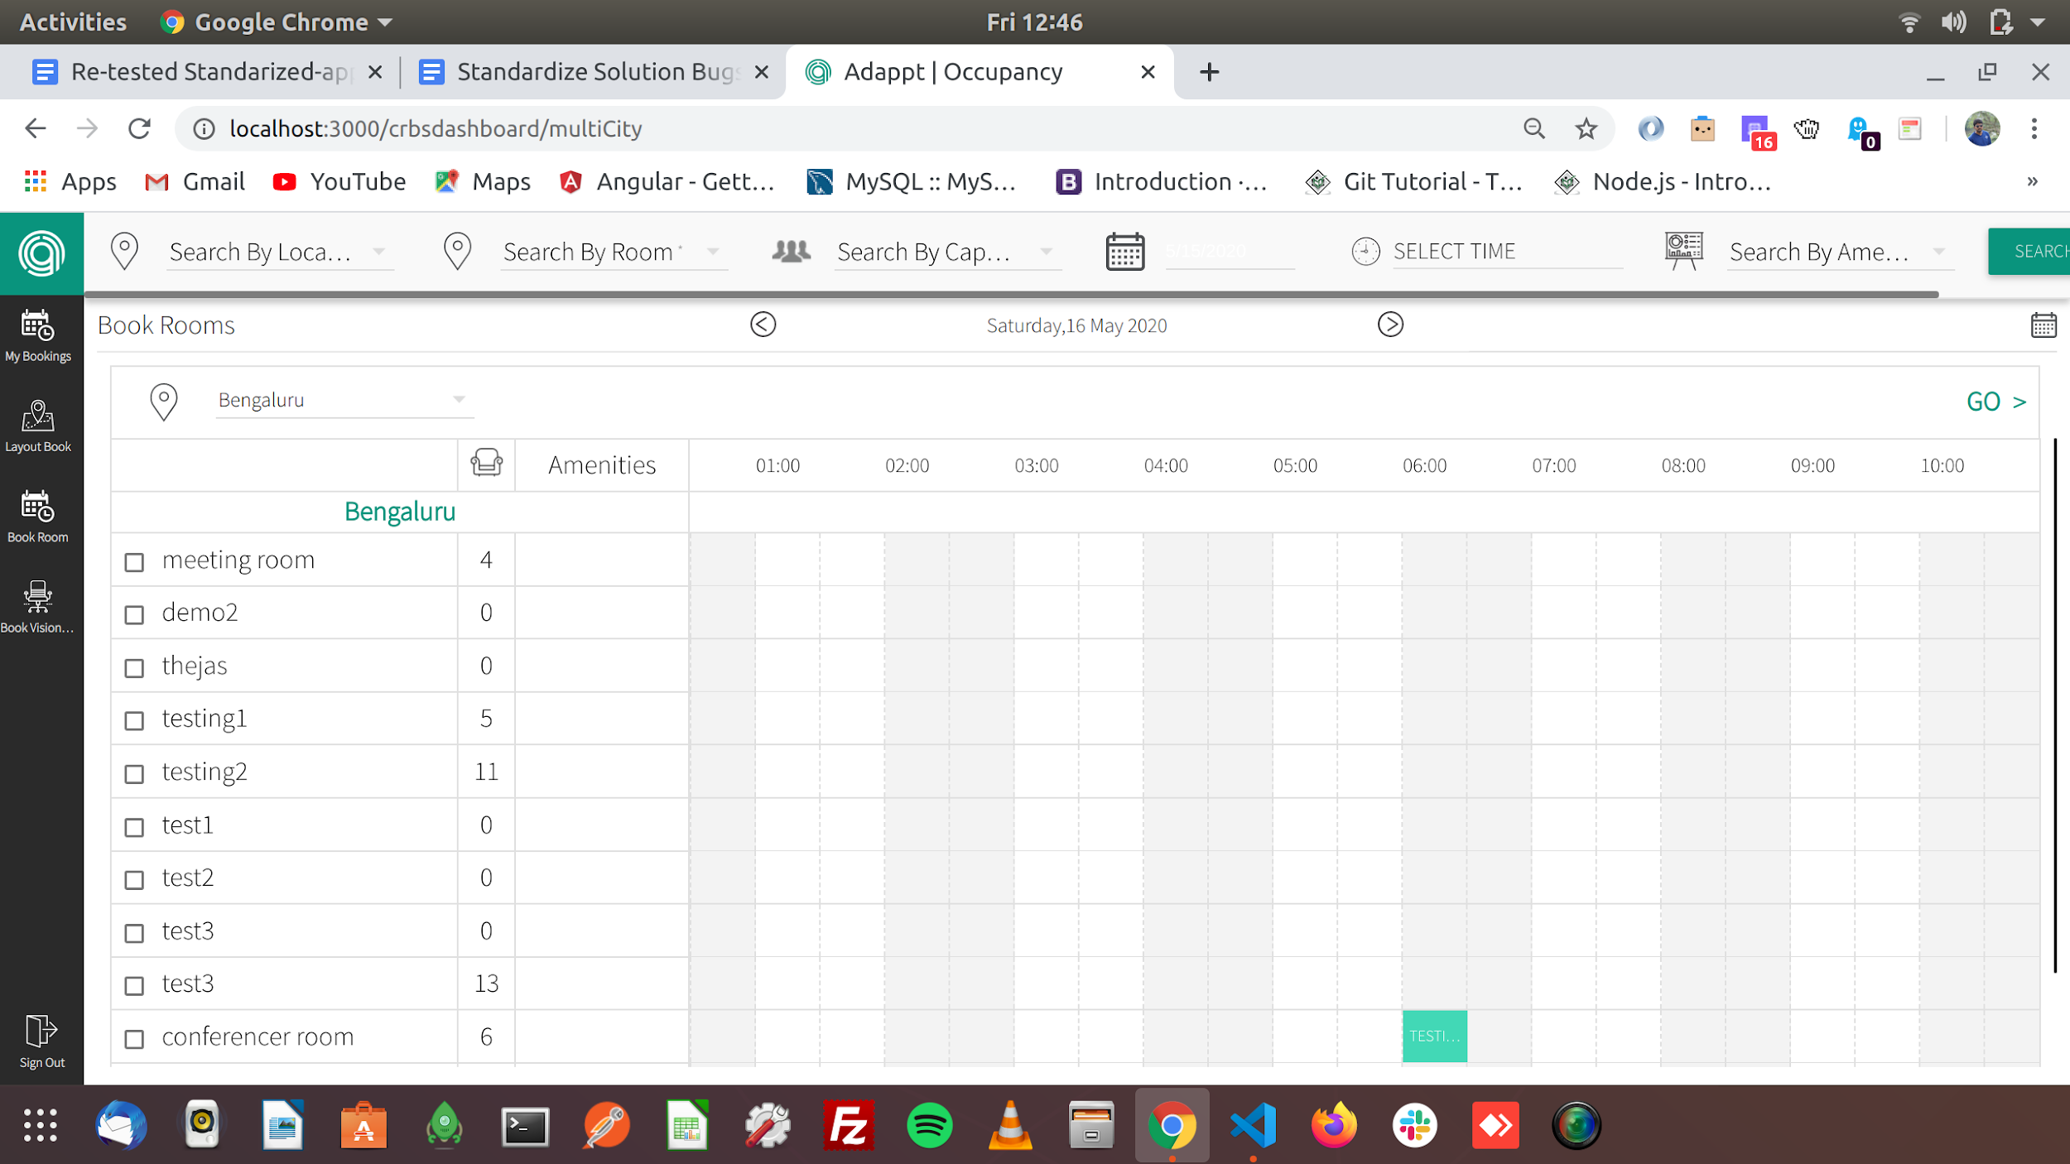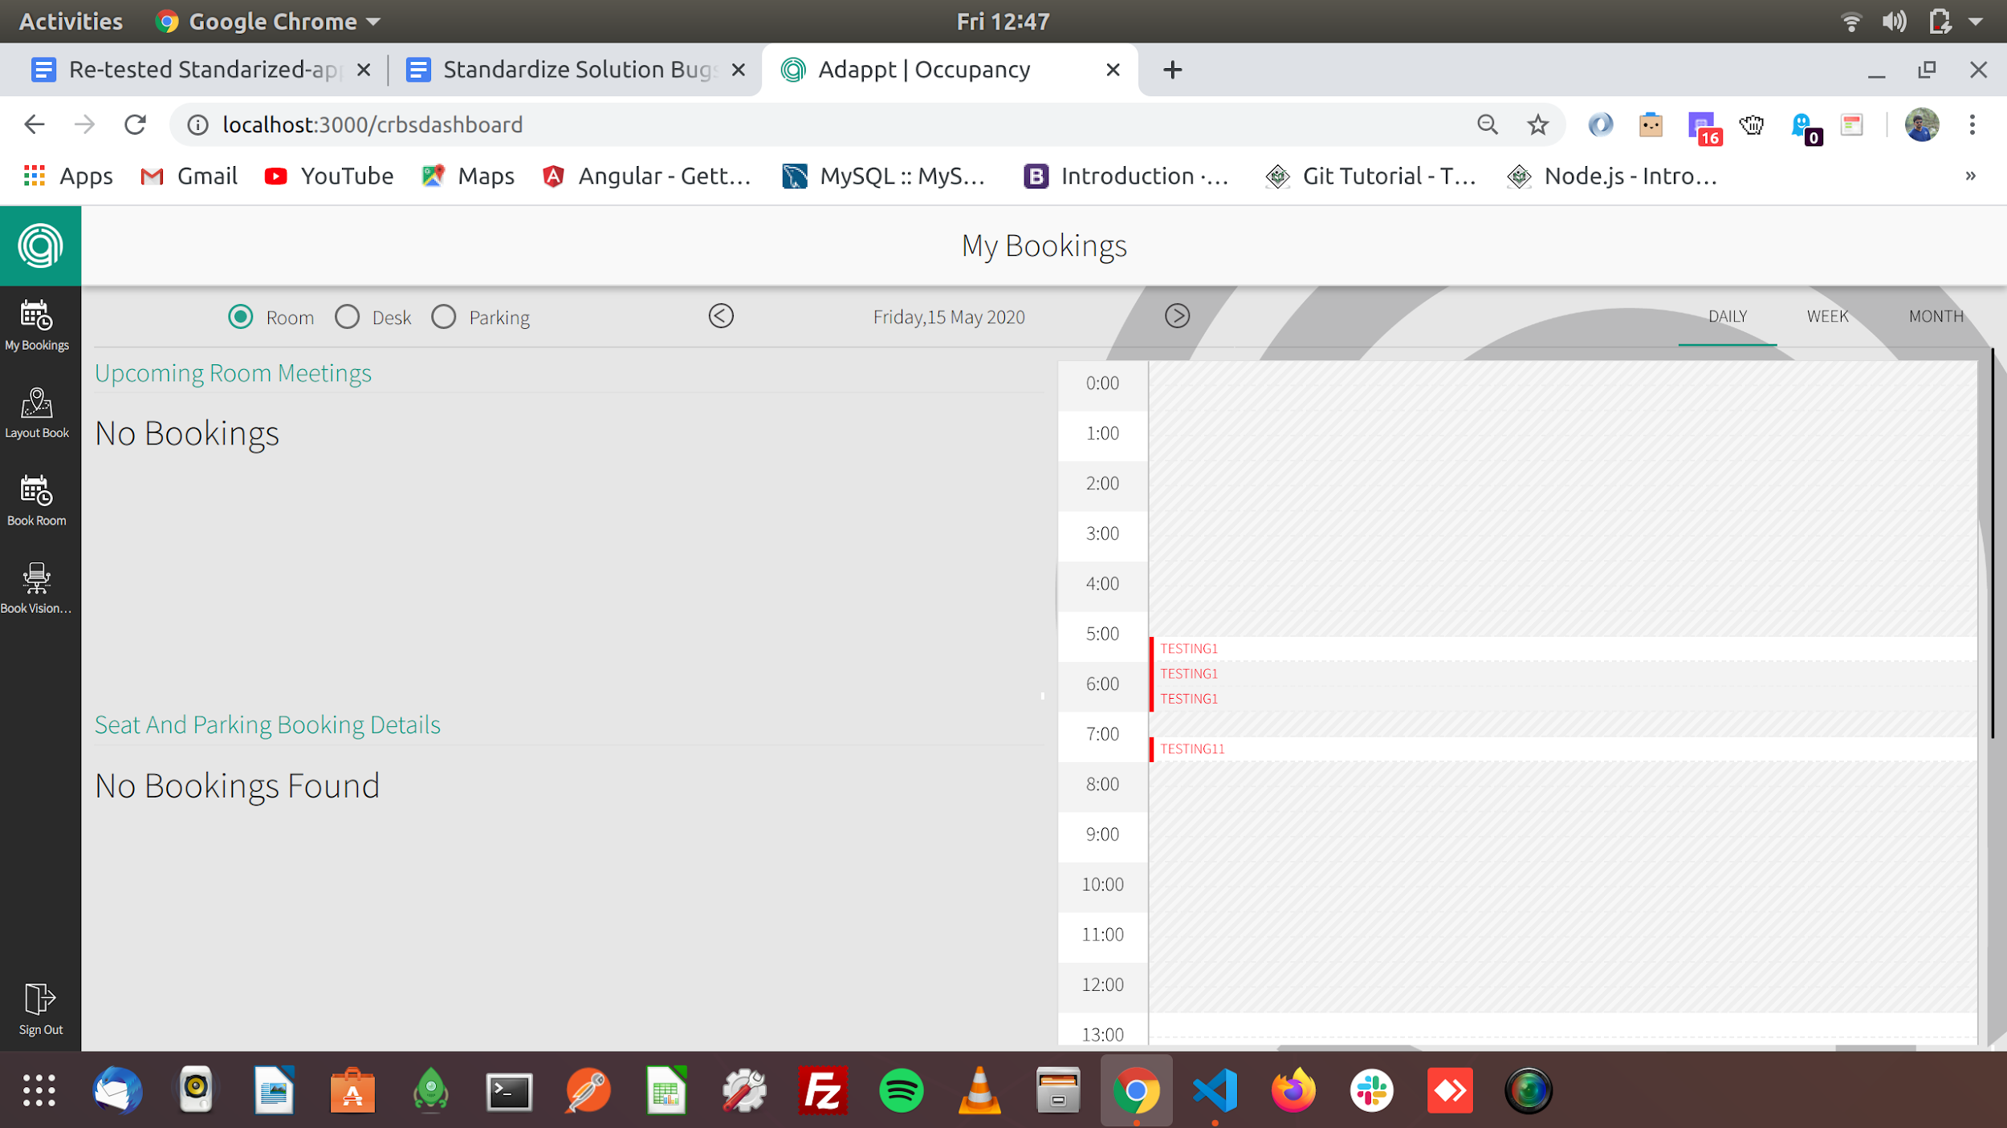
6. In the “Book layout i have given time for 14:00 to 14:30 but it takes different time zone (4:30-5:00)and even if we book without recurring end date it books the layout please check

